M Gmail '
Cora Salmonsen <salmocora@gmail.com>
--- - ------------------·- - -
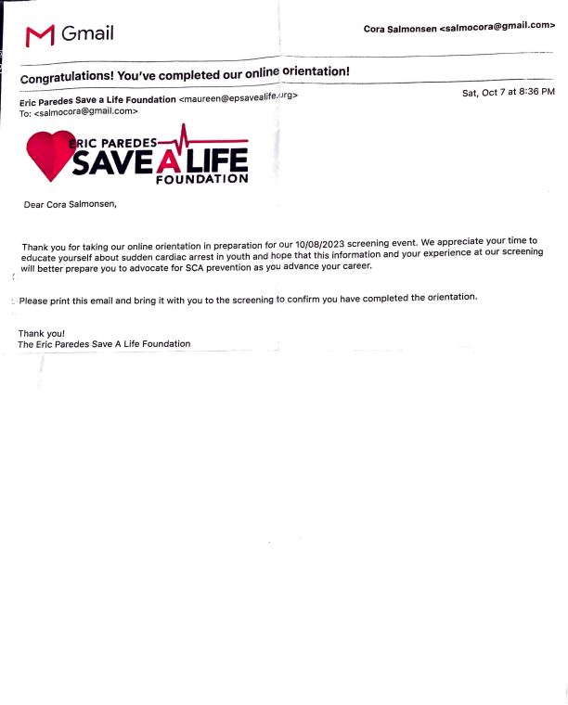
congratulations! You've completed our online_orientation!
Eric Paredes Save a Life Foundation <maureen@epsavealife.urg> To: <salmocora@gmail.com>
IC PAREDES~
AVE/i. LIFE
FOUNDATION
Dear Cora Salmonsen,
Sat, Oct 7 at 8:36 PM
Thank you for taking our online orientation in preparation for our 10/08/2023 screening event. We appreciate your time to educate yourself about sudden cardiac arrest in youth and hope that this information and your experience at our screening will better prepare you to advocate for SCA prevention as you advance your career.
:. · Please print this email and bring it with you to the screening to confirm you have completed the orientation.
Thank you!
The Eric Paredes Save A Life Foundation

