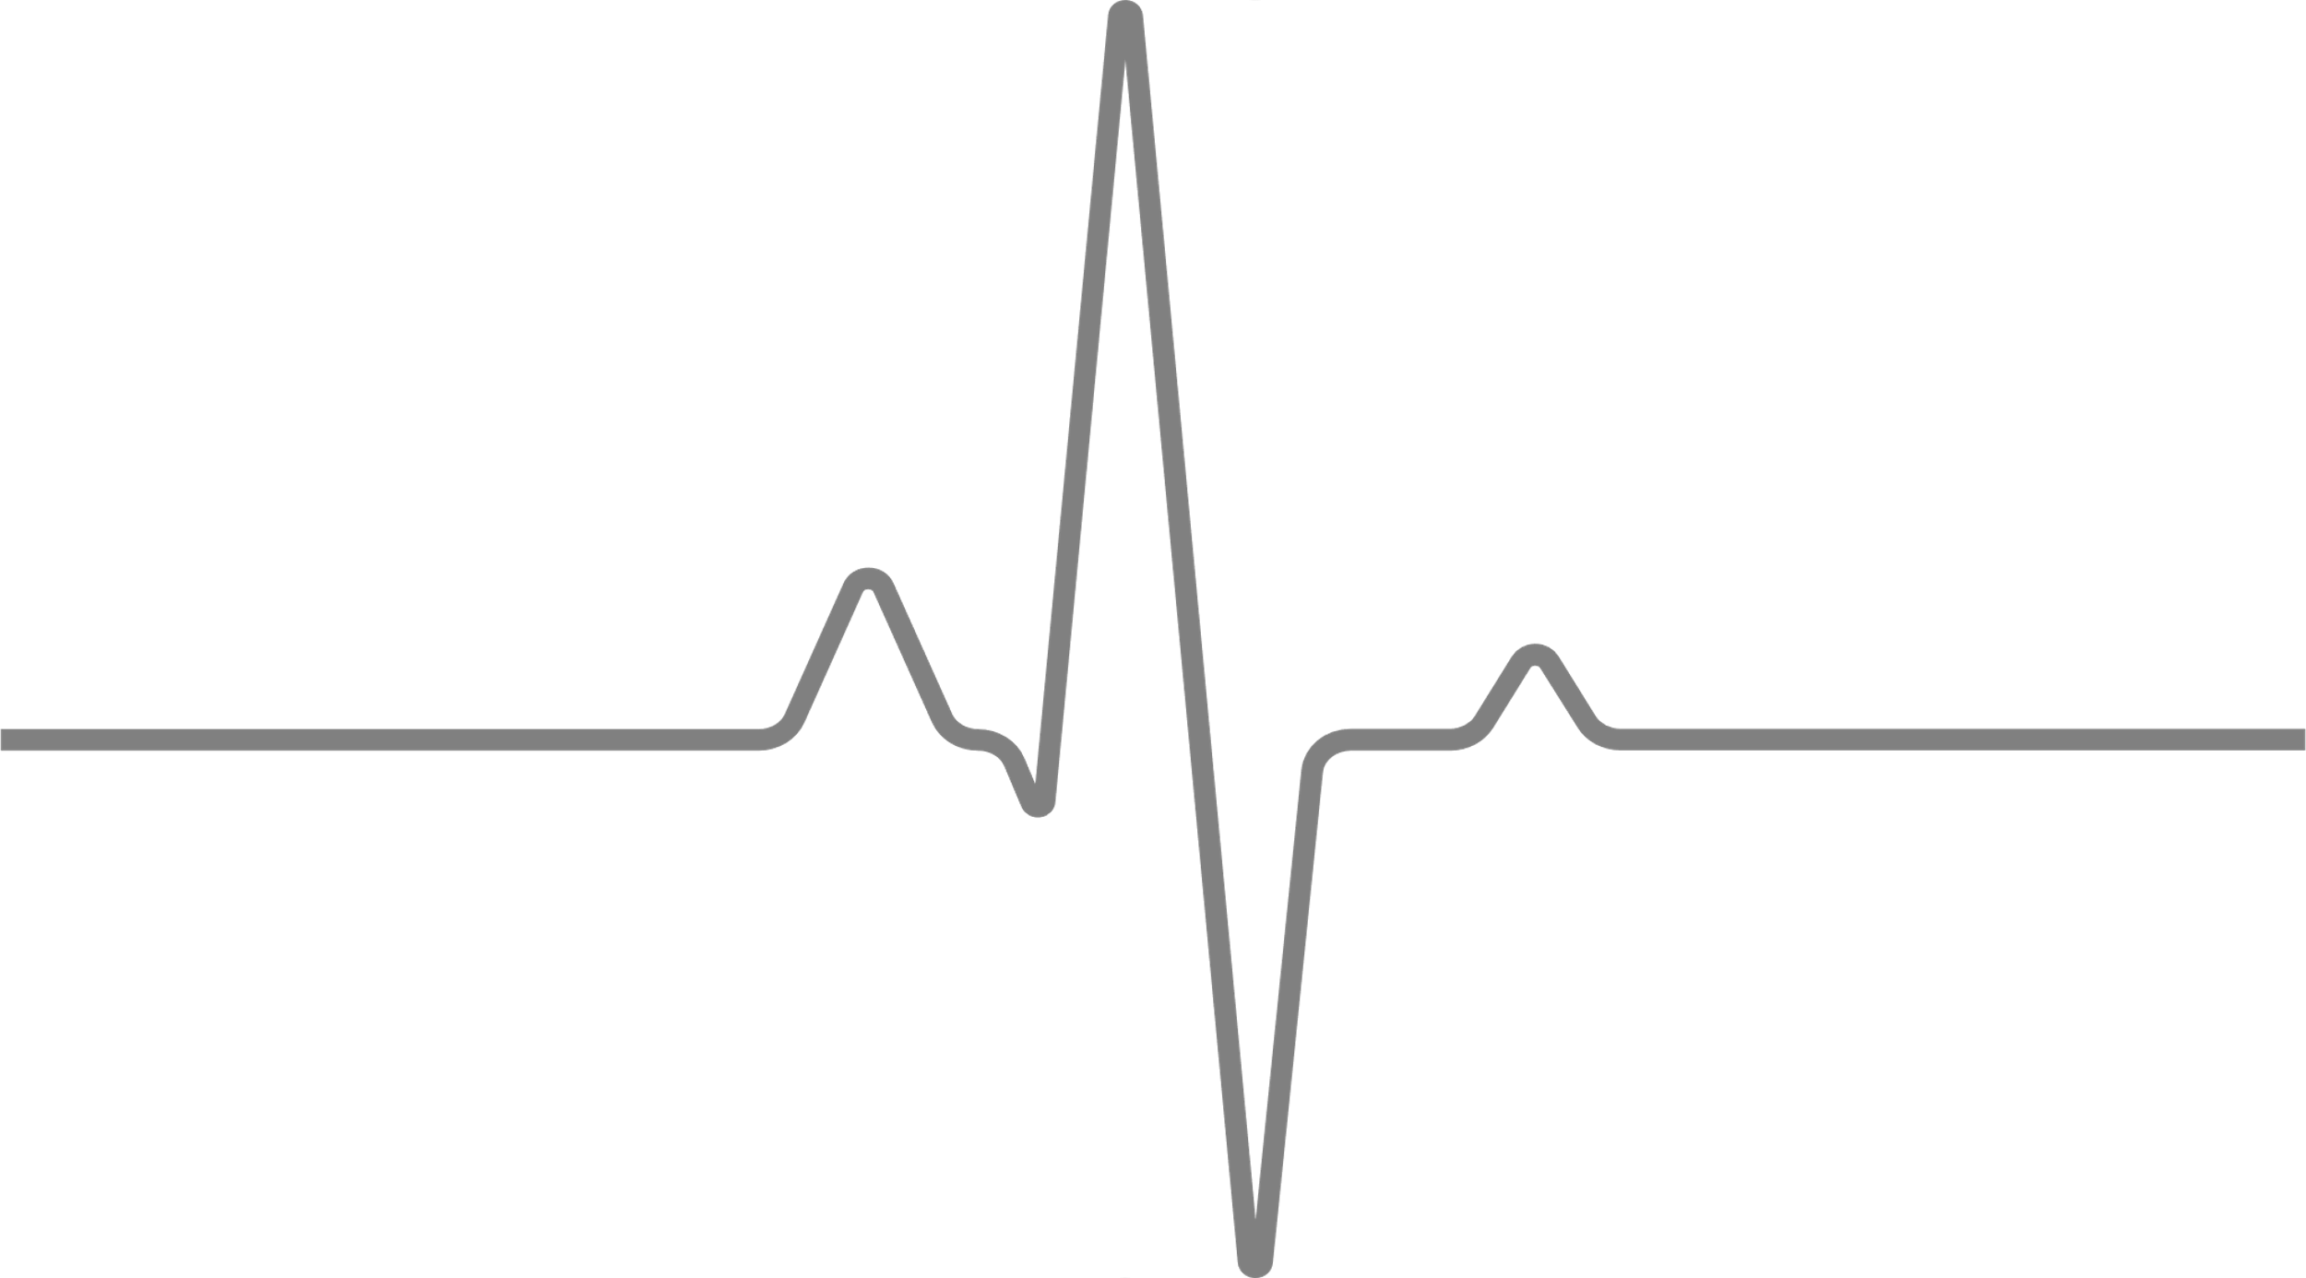
Yadira Loyola
STUDENT NURSE

PROFESSIONAL OVERVIEW
Looking to provide excellent patient care as a new graduate nurse. I am a Spanish medical interpreter and seek to help the Spanish speaking patients in my community.

760-639-8071
Yadira.loyola94@gmail.com
https://www.linkedin.com/in/yadira-loyola-718387293/
https://portfolio.staffgarden.com/yadira-loyola-7189967




EDUCATION
BACHELORS OF SCIENCE IN NURSING, BSN | BOISE, ID
Boise State University 4.0 GPA
2022 – Present (expected August 2024)
Associate in Science Degree, Registered Nursing | OCEANSIDE, CA
MiraCosta College 4.0 GPA
2022 – Expected December 2023

General ED | MENIFEE, CA
Mt. San Jacinto College
2020 – 2021
WORK EXPERIENCE
Unit Secretary/ Spanish Medical Interpreter
Palomar Health, Poway CA | June 2014 - Present
- Provide administrative and clerical support to the unit
- Maintain communication between clinicians and other departments
- Achievements: Star of the Quarter Award, Employee of the Quarter Award, Secretary of the Year Award (x3), implemented/organized process for managing/ordering forms and supplies, collaborated on the development of downtime process for the department

Tele-Psychiatry Care Coordinator
Vituity Healthcare, Remote | March 2019 – March 2020
- Handle high volume of calls from providers to schedule psychiatric consults
- Triage requests/prioritize consults
Unit Secretary
Scripps Health, Encinitas CA | June 2016 – November 2016
- Provides administrative /clerical support for the department
- Maintain and update medical records
- Maintain communication between clinicians and other departments
Nutrition Care Assistant
Palomar Health, Escondido CA | November 2012 – June 2014
- Assist patients with meal selections over the phone and in person
- Knowledge in therapeutic diets

LICENSES & CERTIFICATIONS
PALS, Pediatric Advanced Life Support
American Heart Association
Expires 08/2025

ACLS, Advanced Cardiac Life Support
American Heart Association
Expires 08/2025

BLS, Basic Life Support
American Heart Association
Expires 09/2024

NIHSS, Stroke Scale
American Heart Association
Expires 09/2024

