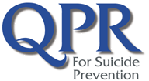 QPR Gatekeeper Certificate

Cora Salmonsen
has met all the requirements of the course:

QPR Suicide Prevention Gatekeeper Program

Presented by:

Community Health Improvement Partners

Joyce Bruggeman
QPR Certified Gatekeeper Instructor

1.5 Clock Hours
October 26, 2023 NBCC Provider #5889

